**Conceptual Modelling Lab 2**

In this lab we continue to work through the Hierarchical Control Conceptual Modelling (HCCM) framework to build a conceptual model, aligned with the HCCM standard from lectures, that represents the practical activity, i.e., making paper cubes, from the earlier lab.

You will finish working through the steps for HCCM modelling shown below and complete templates for those steps.

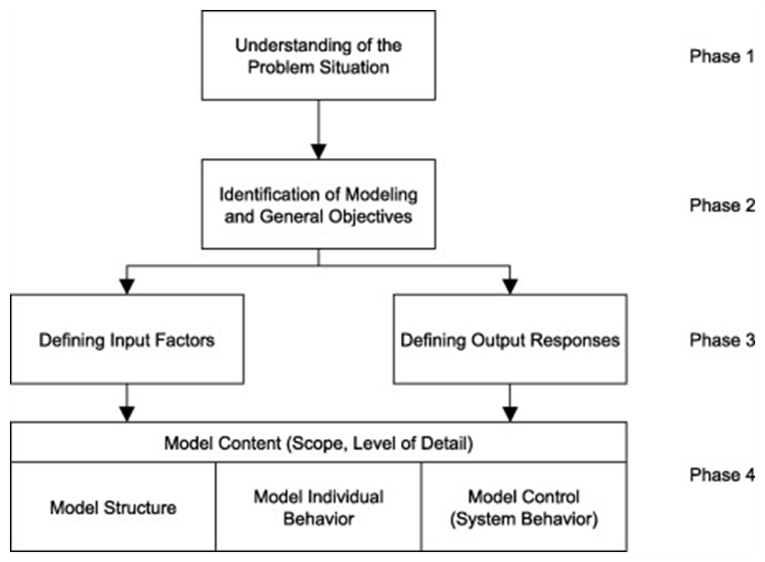

# Understanding of the Problem Situation Identification of Modelling and General Objectives

**~~Modelling Objectives~~**

**~~General Objectives~~**

# Defining Input Factors Defining Output Responses Model Content

Recall that for the model content definition of our conceptual model we will follow the new HCCM standard. This standard is presented in an academic article (currently under review) that is available on Canvas under

Files > Lectures > Conceptual Modelling in the file [hccm-standard.pdf](https://canvas.auckland.ac.nz/courses/87546/files/folder/Lectures/Conceptual%20Modelling?preview=11293700)

# Identifying Entities Drawing Behavioural Paths

## Model Control – Defining Logic

Now that the behavioural paths of the active entities have been defined (in the last lab) you need to define the logic for each of your triggers (the little red squares). In the box below the logic for one of those red squares – triggered on the start of Wait for Cur Cube Shape – is shown along with a reminder of snippets of the behaviorual paths that are relevant to this trigger. In this box and the next two write down pseudocode for all your triggers.

|  |  |  |
| --- | --- | --- |
| **On Start Wait for Cut Cube Shape** | |  |
| **Triggered by** | Cube *c* |  |
| 1: **if** Scissors.CurrentActivity = Wait for Scissors Task **then**  2: Wait for Scissors Task.End with Scissors  3: TRANSITION Wait for Scissors Task.End to Cut Cube Shape.Start WITH Scisso  4: Cut Cube Shape.Start with Scissors and *c*  5: **end if** | | rs |
| start/end  Event  Activity  Scheduled  Controlled  start/end  Activity  withstart  trigger  Activity  withend  trigger  Scissors  Created  Waitfor  Scissors  Task  CutCube  Shape  CutTape  ···  WaitforCut  CubeShape  CutCube  Shape  ··· | |  |

## Defining Logic (continued)

## Defining Logic (continued)

Numtapestrips = parameter for how many times more tape cut is needed than paper

On Start: Wait for CutTask

Triggered by: Scissors

If Person.CurrentActivity == waitforpersontask then

If has Paper.WaitforCut && PaperBeenCut < numtapestrips* TapeBeenCut then:

CutPaper.Start WITH oldest Paper in Paper.WaitforCut, Scissors, Person

Else:

CutTape.Start WITH Scissors, Person

End if

WaitforCutTask.End

Do CutTape

Do CutPaper

Wait for CutTask

On Start: Wait for PersonTask

Triggered by: Person

If NOT has SufficientTape && Scissors.WaitForCutTask:

Do CutTape WITH Person, Scissors

Elseif has Paper.WaitforMakeCube && has SufficientTape:

Do MakeCube WITH Person, TapeBeenCut, Paper

Elseif has Paper.WaitforCutPaper && Scissors.WaitForCutTask:

Do CutPaper WITH Person, Scissors, Paper

Elseif has Paper.WaitforDrawNet:

Do DrawNet WITH Person, Paper

WaitforPersonTask.End

Do CutPaper

Do CutTape

Do DrawNet

Do MakeCube

WaitforPersonTask

tapeneeded = amount of tape needed to tape 1 cube

On Start: Wait for CutTape

Triggered by: Tape

Tape.Activity = WaitforCutTape

Waitfor Do CutTape

Tape.Activity = Do CutTape

TapeBeenCut += 1

Totalneeded = tapeneeded*(num Paper.Activity=WaitForMakeCube + num Paper.Activity=MakeCube)

If TapeBeenCut >= Totalneeded then SufficientTape = TRUE else FALSE

Do CutTape

WaitforCutTape

On Start: Wait for DrawNet

Triggered by: Paper

Paper.Activity = WaitForDrawNet

Waitfor Do DrawNet

Paper.Activity = DoDrawNet

On Start: Wait for CutPaper

Triggered by: Paper

Paper.Activity = WaitForCutPaper

Waitfor Do CutPaper

Paper.Activity = DoCutPaper

On Start: Wait for MakeCube On End: DoMakeCube

Triggered by: Paper Triggered by: Paper

Paper.Activity = WaitForMakeCube Paper.Activity = Cube

Waitfor Do MakeCube NumCubes += 1

Paper.Activity = MakeCube

Do DrawNet

Waitfor DrawNet

Waitfor CutPaper

Do CutPaper

Waitfor MakeCube

Do MakeCube

Checkpoint Get the lab tutors to review and mark off your logic pseudocode.

## Model Data

Finally, you need to give detailed defintions of the data, entities, transitions, activities and events. You may not have collected data during cube making, but fill out the following table that describes the kind of data you would need to collect to simulate cube making.

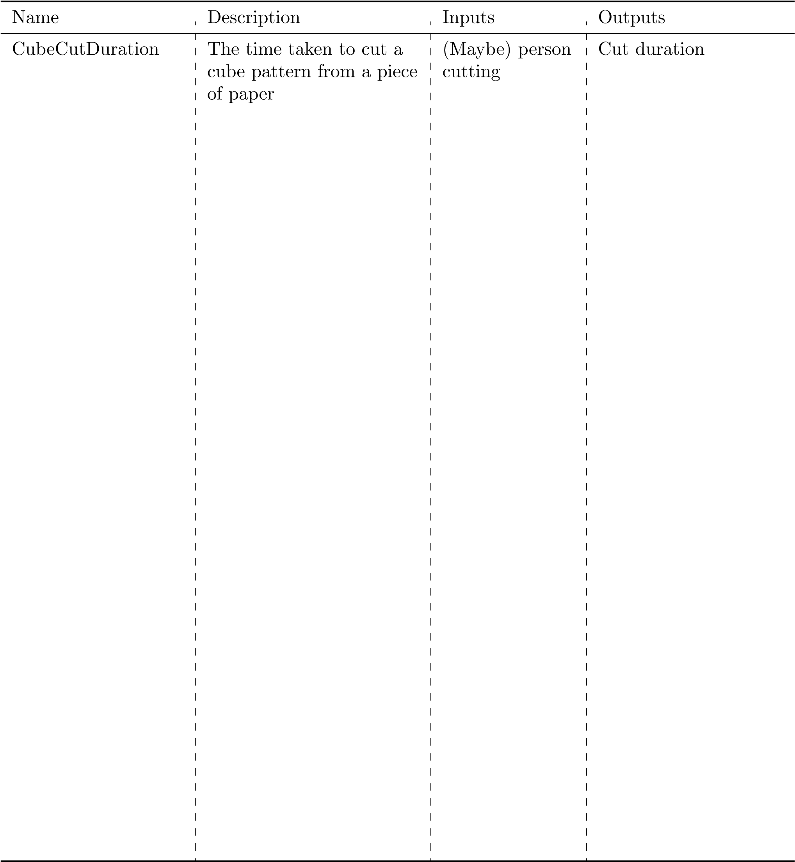

## Model Entities

In the following table list the entities again, but add attributes that the entities will need to capture the performance of the system, e.g., waiting time until the cube was cut. The Cube entity has been started for you.

Entity

Attributes

Description

Thenumberofthecubebeing

Cube

Number

cut

CurrentStart

Whendiditstartthecurrentac-

tivityitisparticipatingin

Whatisthecurrentactivityitis

CurrentActivity

participatingin

Howlongdiditwaituntilitwas

WaitingForCubeCutTime

cutfromasheetofpaper

## Model Transitions

In the following table list the transitions between activities and events. Not that you may want to prefix these transitions by the behavioural pathway they come from.

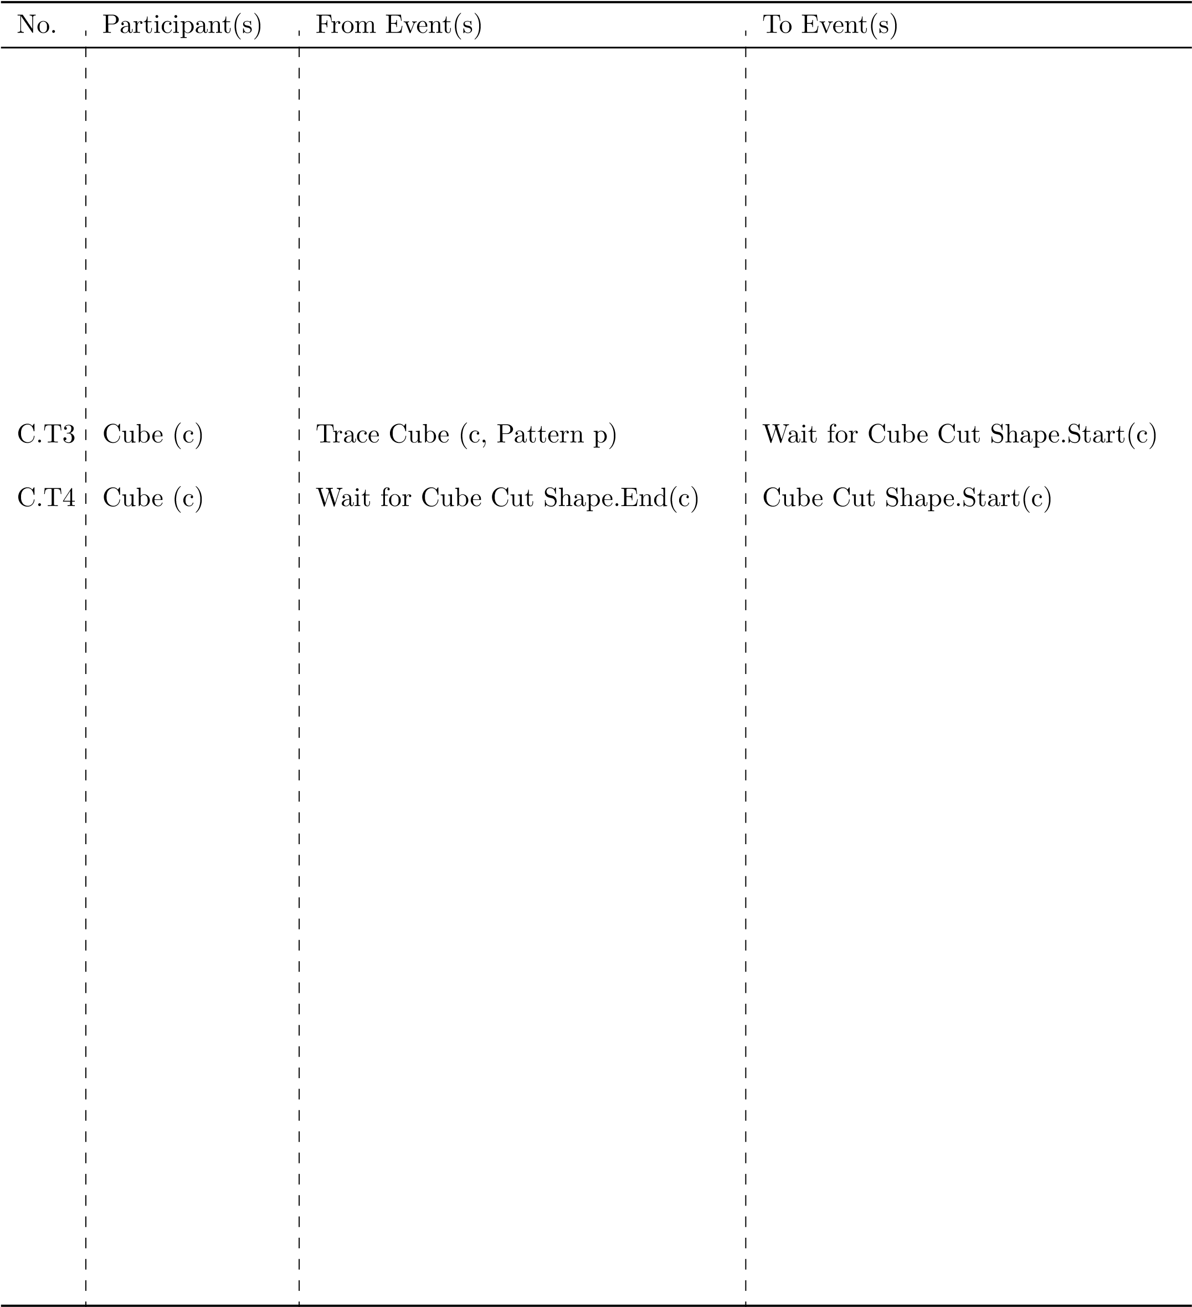

## Model Activities

In the following table list the activities from the behavioural pathway diagrams along with the state changes for the start and end event of each activity.

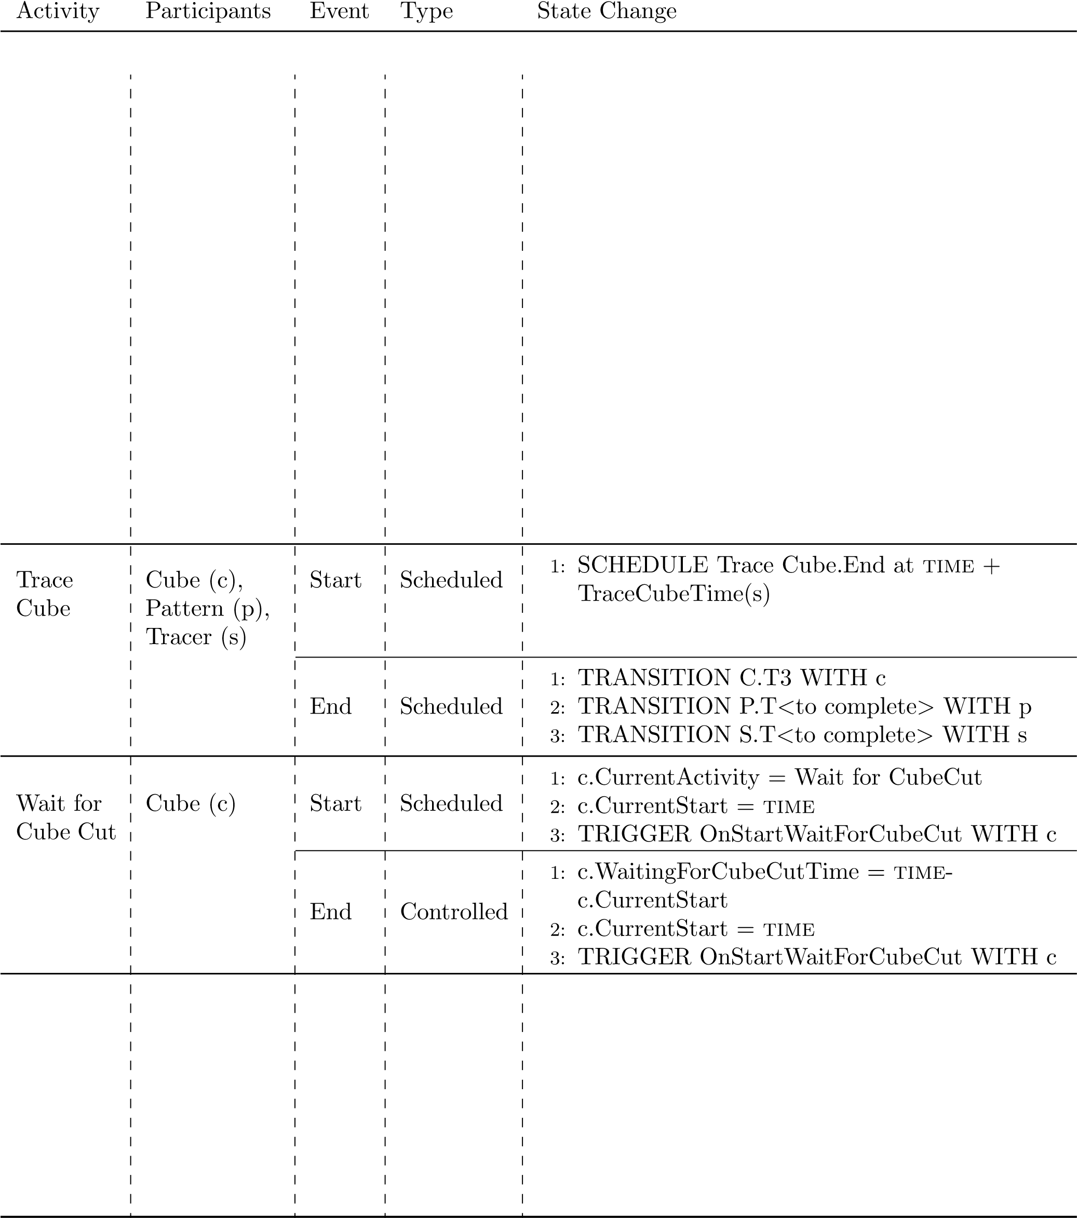

## Model Activities (continued)

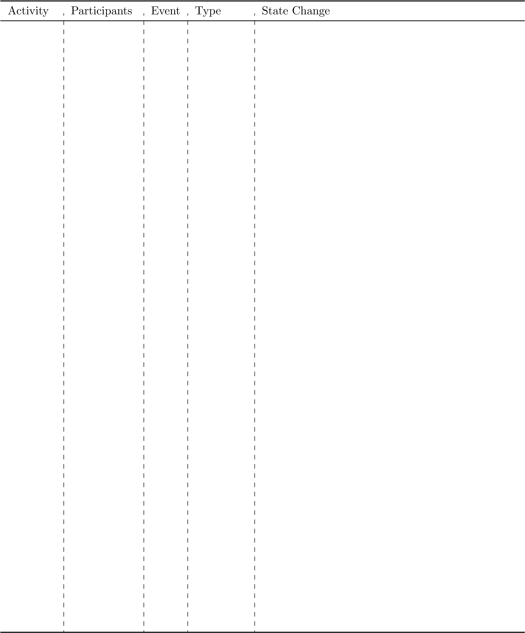

## Model Activities (continued)



## Model Events

In the following table list the events to start and finish the simulation along with the events from the behavioural pathway diagrams along with the state changes for each event.

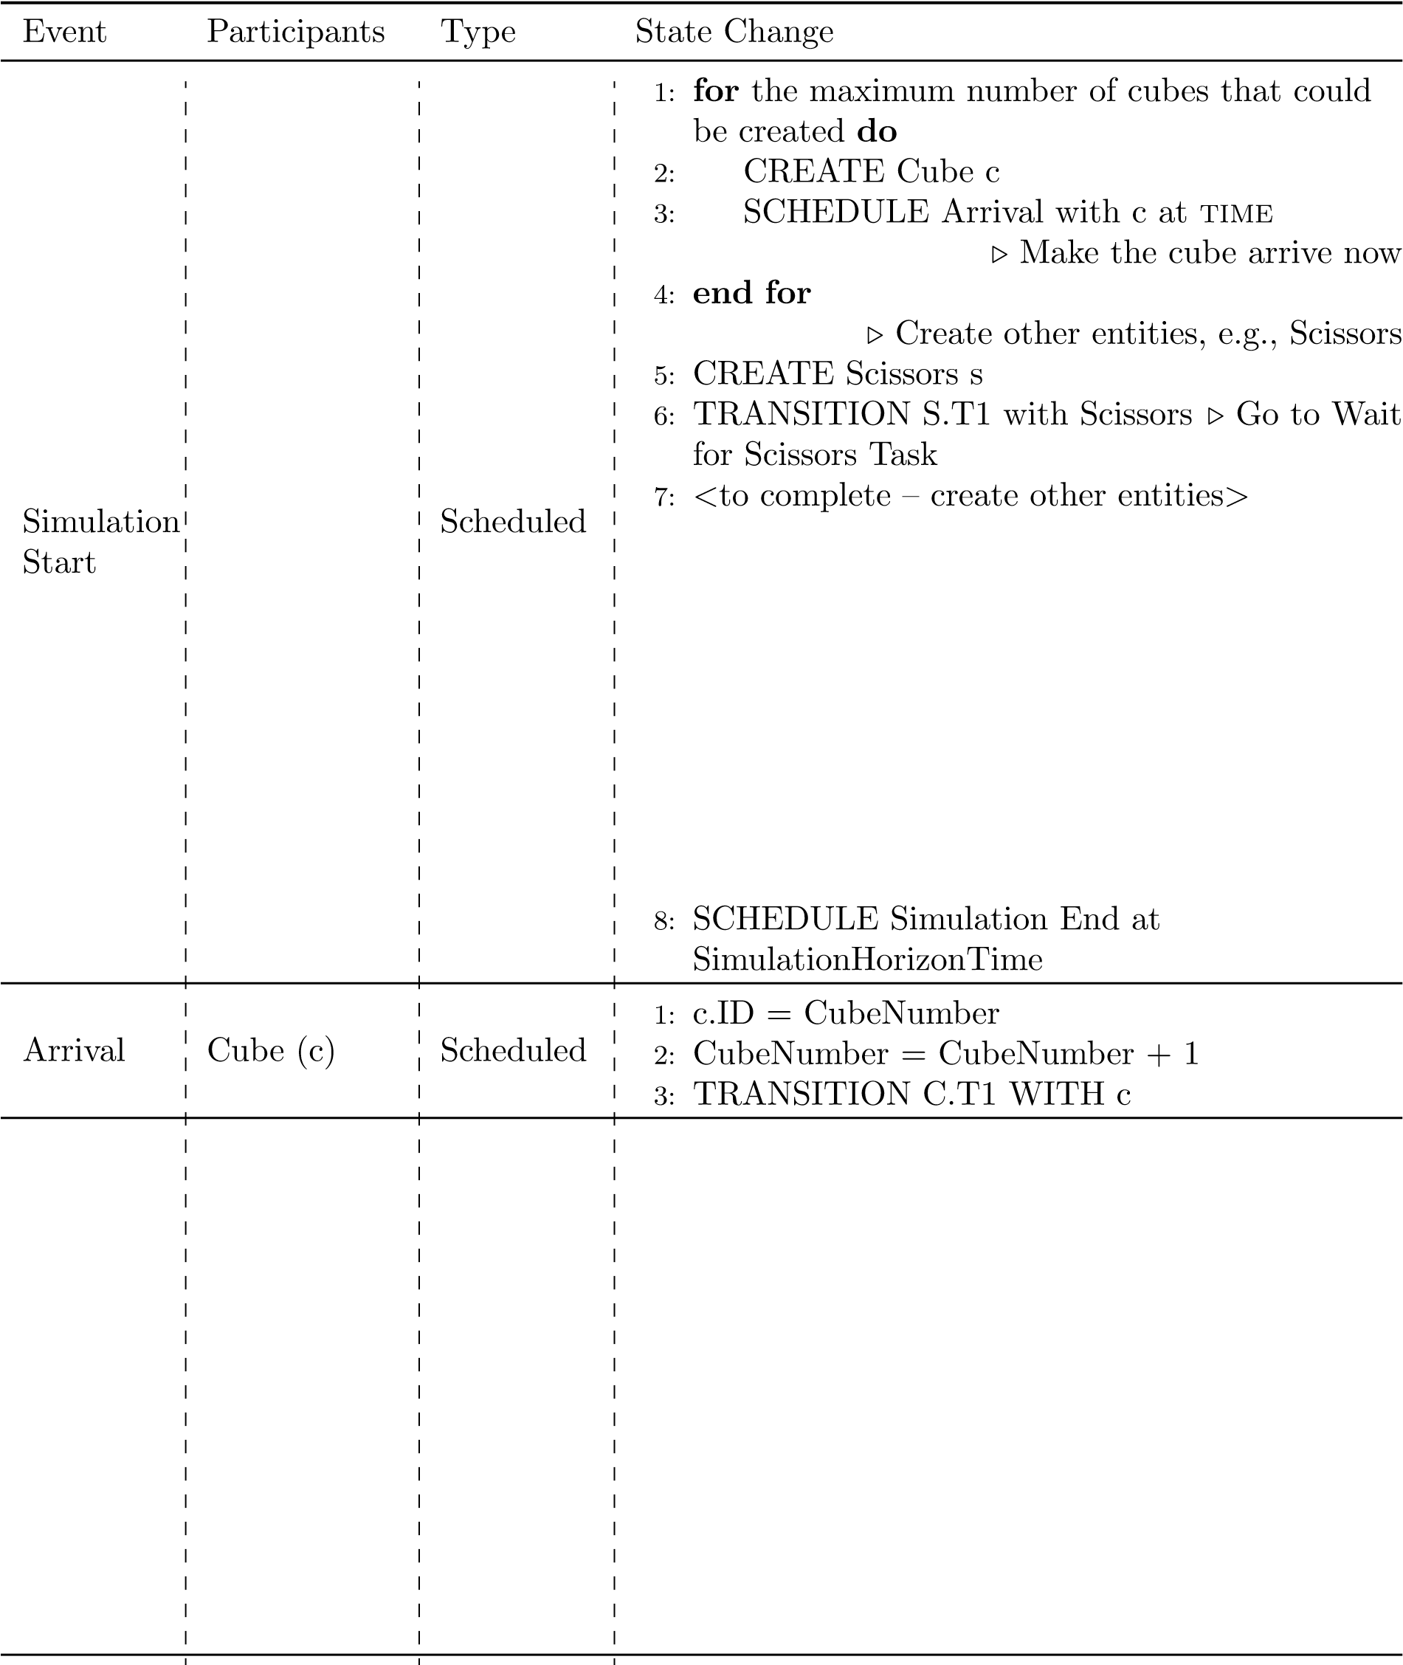

## Model Events (continued)

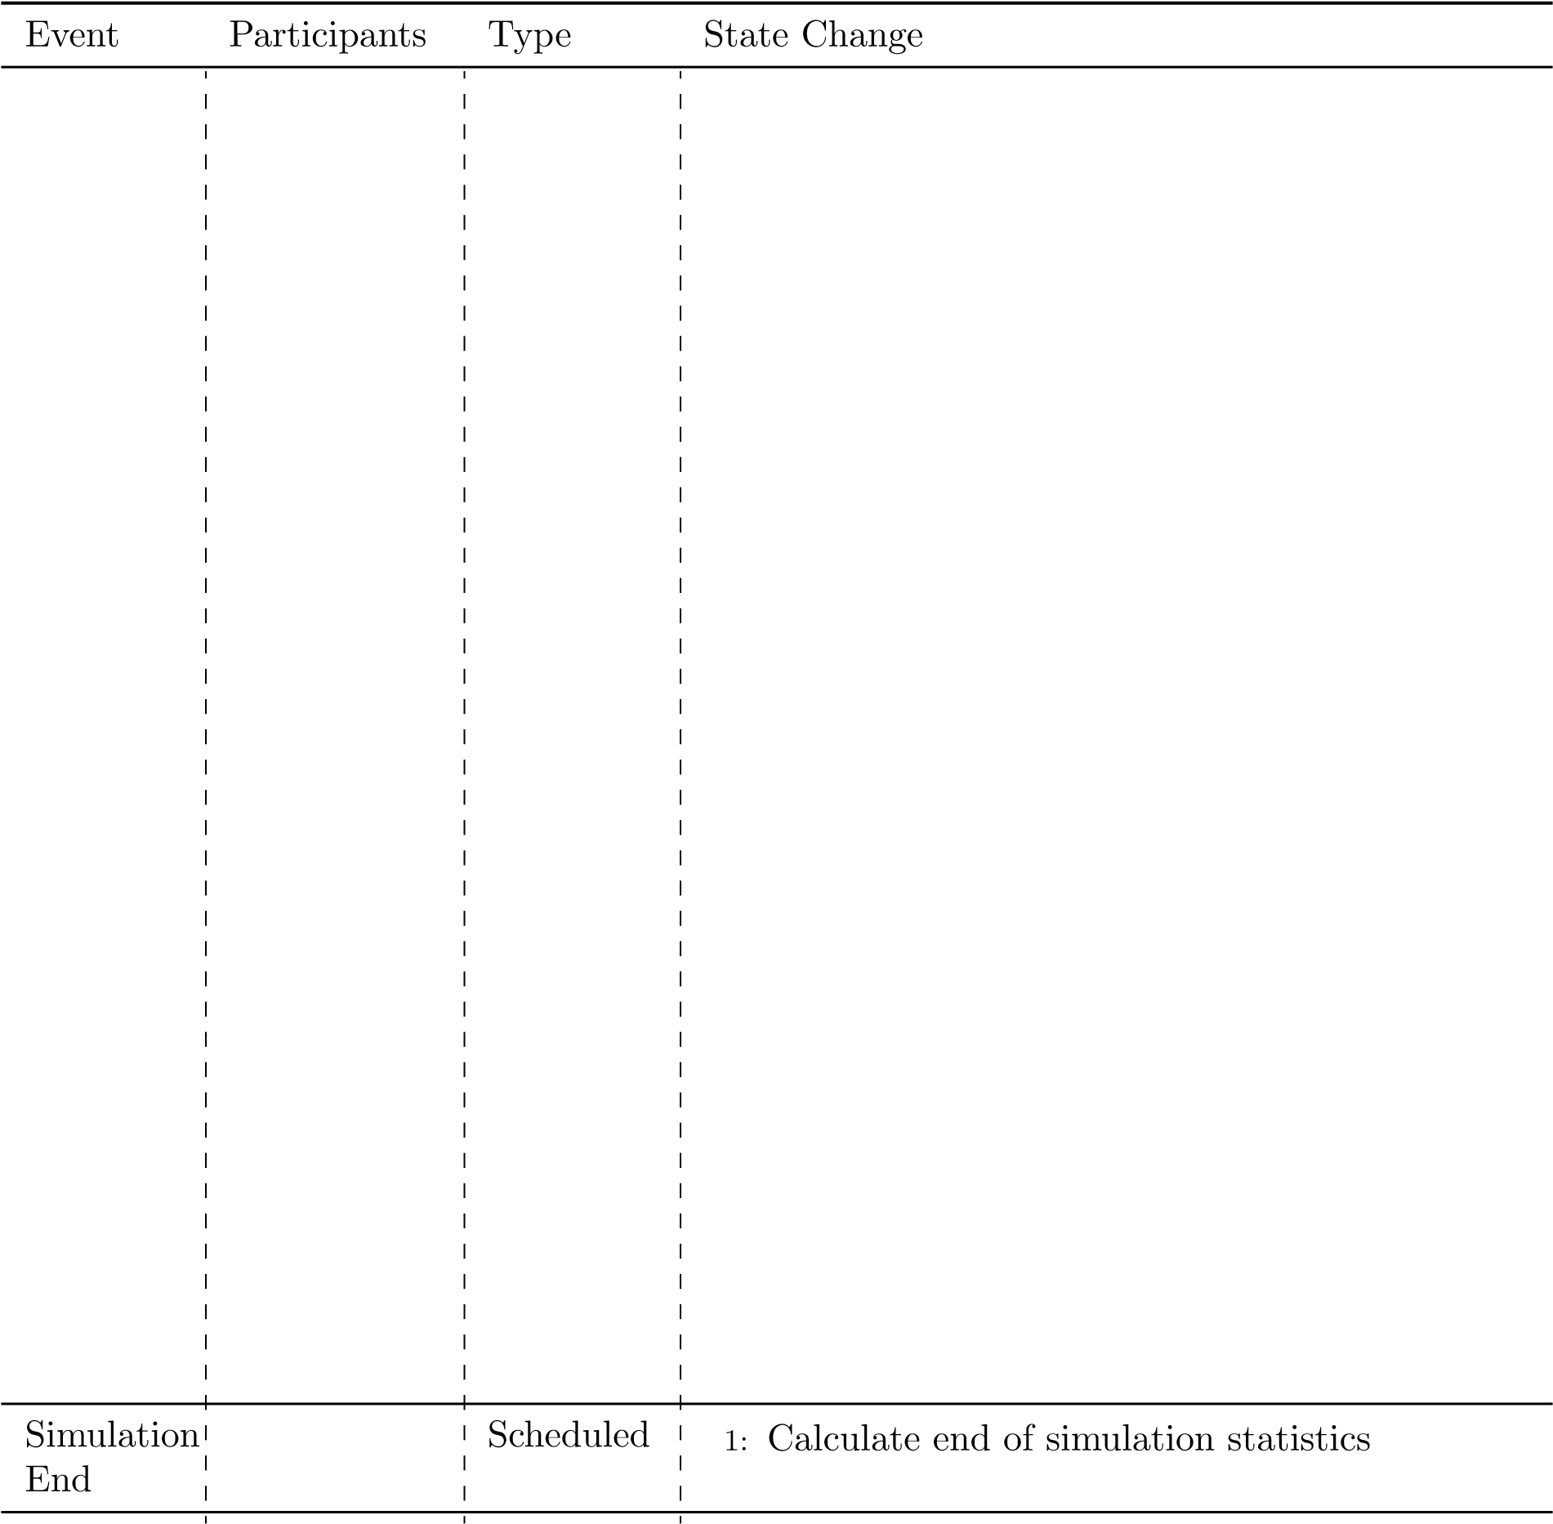

Checkpoint Get the lab tutors to review and mark off your tables. You will need your behavioural pathways handy to show them how you have translated those pathways into tables.

You have now completed the conceptual model of the cube making activity and you could use this model as the staring point for implementing a simulation model in JaamSim using the HCCM library.